ANNOTATION FRAME SCRIPT V0.3

# Purpose of the script

This script automatically adds a frame around an image. A title can be placed above the image. Below the image 3x3 lines of annotations can be included.

All font scaling and alignment is automatically done by the script.

The script unfortunately has no dynamic interface to see the results of the operation in real-time. However, provisions have been taken so you can try out and adjust parameters to get to an optimal result.

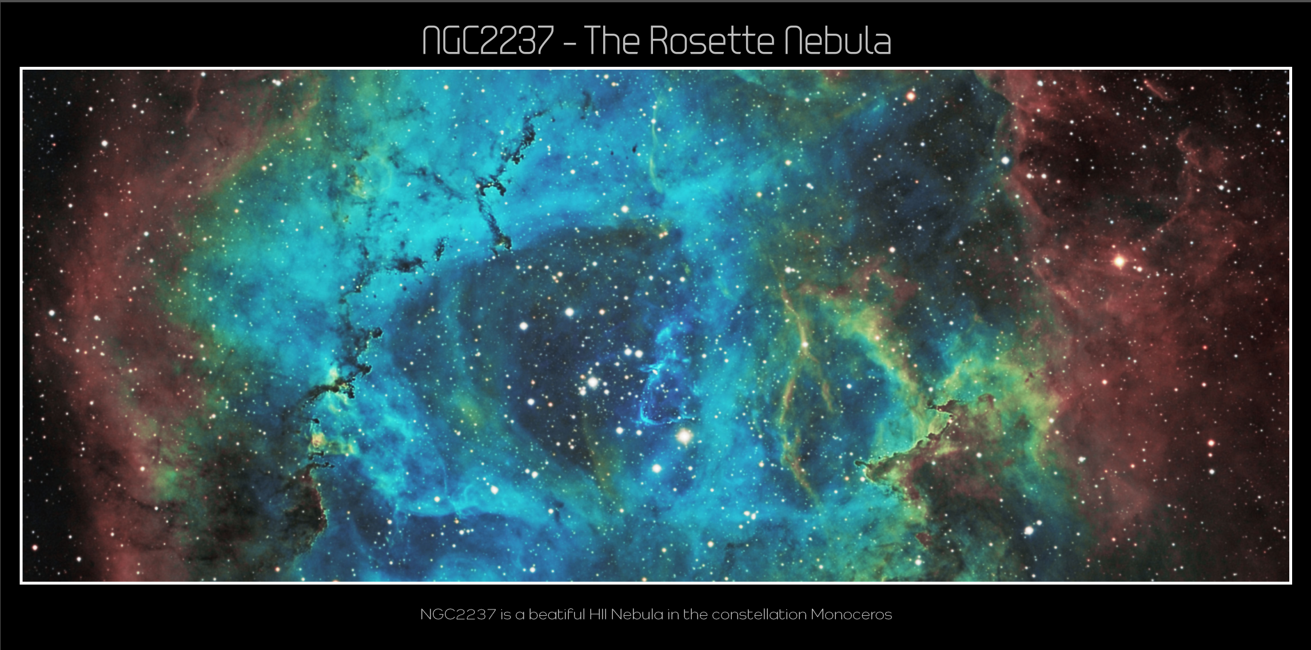

Figure 1 - An example framed image

# user interface

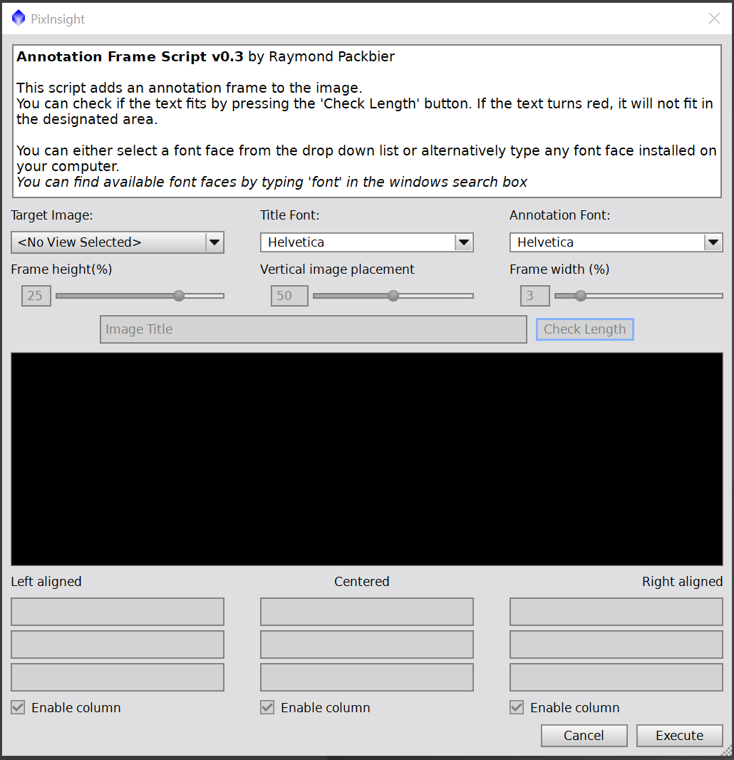

Figure - The User Interface

The basic operation and detailed parameters are described in the following chapters.

# basic Operating instructions

* The user needs to specify the image to process (control *Target Image*).
* The user needs to specify how much space will be created around the picture vertically and horizontally (controls *frame height* and *frame width*).
* The user needs to specify the placing of the picture in vertical direction (control *Vertical Image Placement):*
  + 50% will center the picture vertically, creating equal space for title text and annotations at the bottom.
  + 0% will put the image at the bottom, giving almost all space for the title text.
  + 100% will put the image at the top, giving almost all space for the annotations at the bottom.
* The user needs to specify the font to be used (controls *Title Font* and *Annotation Font)*:
  + Standard fonts can be selected from the drop-down list.
  + Other windows fonts can be used by typing their name in the textbox.
* The user then needs to specify the title text.
* Additionally, the user can enter annotation text below the image.
  + Three columns can be selected individually:
    - If a column is deselected, the adjacent columns will get more space.
* The script will then scale the fonts to fit automatically[1] in the vertical dimension.
  + This means that for larger fonts, the text needs to be shorter to also fit in the horizontal direction.
  + If the text is too long to fit, you need to reduce the vertical space to automatically scale down the font:
    - There is a feedback option (button *Check* Length) to check if the text will fit in the designated space. If a text string is too long to fit, it will turn red.
* Pressing the *‘Execute’* button will run the script and save the setting in the FITS parameters of the image.
* Pressing *‘Cancel’* will exit the script WITHOUT saving the settings.

# parameters

## Frame height (%)

The *frame height* is specified as percent of the picture height. By increasing the parameter, there will be more vertical space for the text, thus leading to bigger characters.

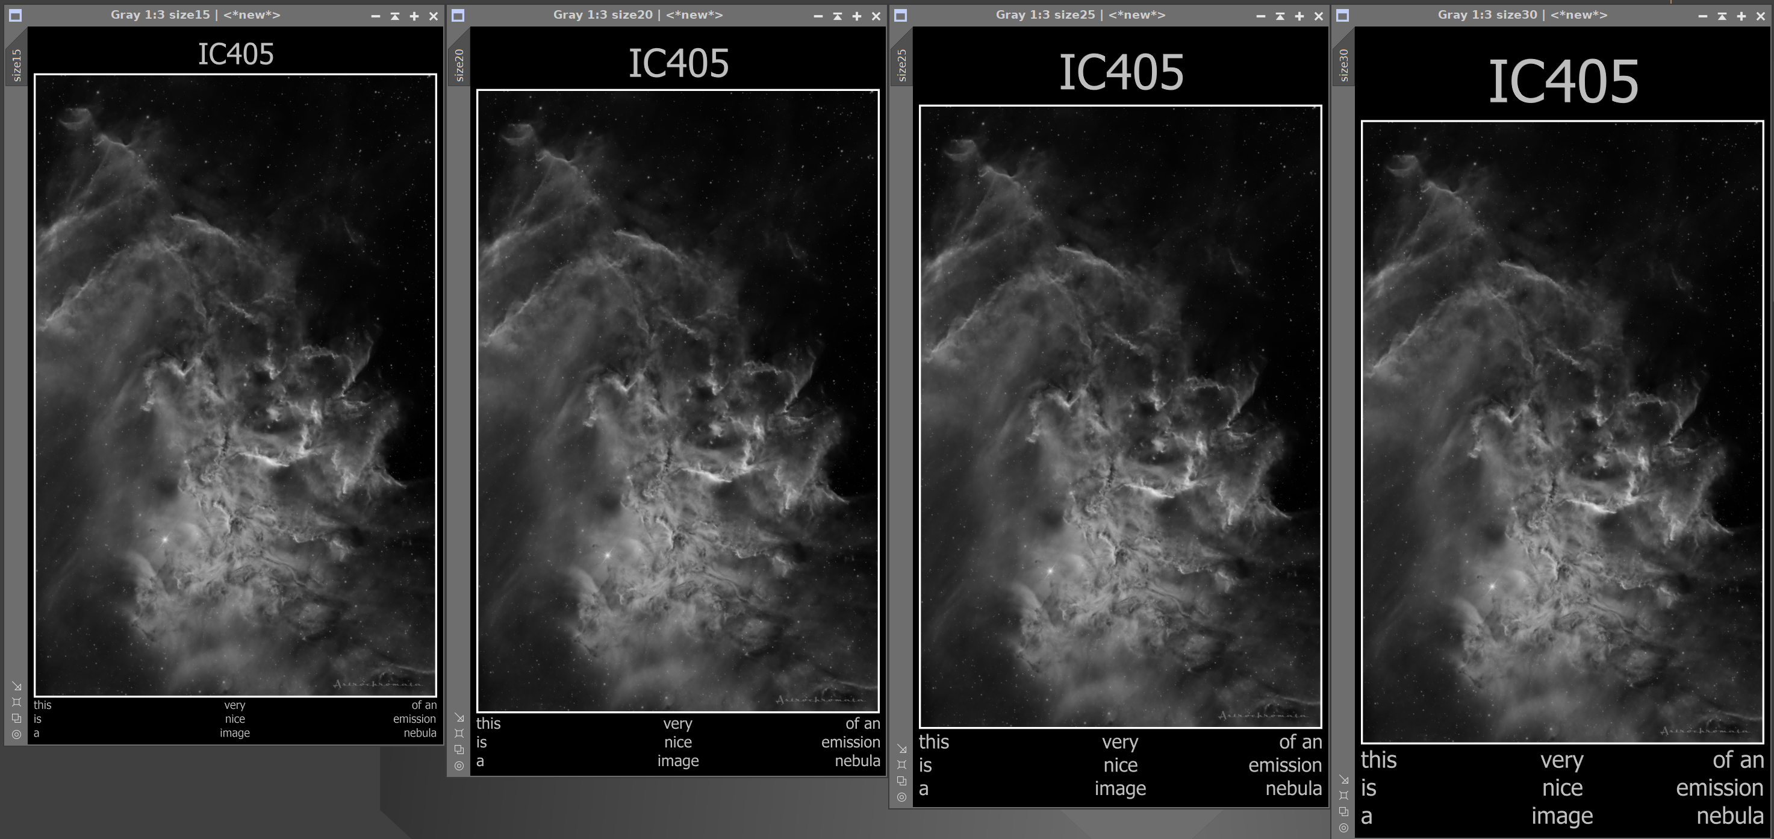

Figure 3 - *Frame Height* Settings 15%, 20%, 25% and 30%

## Vertical Image Placement

The *vertical image placement* determines where the picture frame is placed. A setting of 50% puts the picture frame in the middle. Lower values will put it towards the bottom.  
In this manner, the bottom text can be made smaller in favor of the title text, or vice versa.

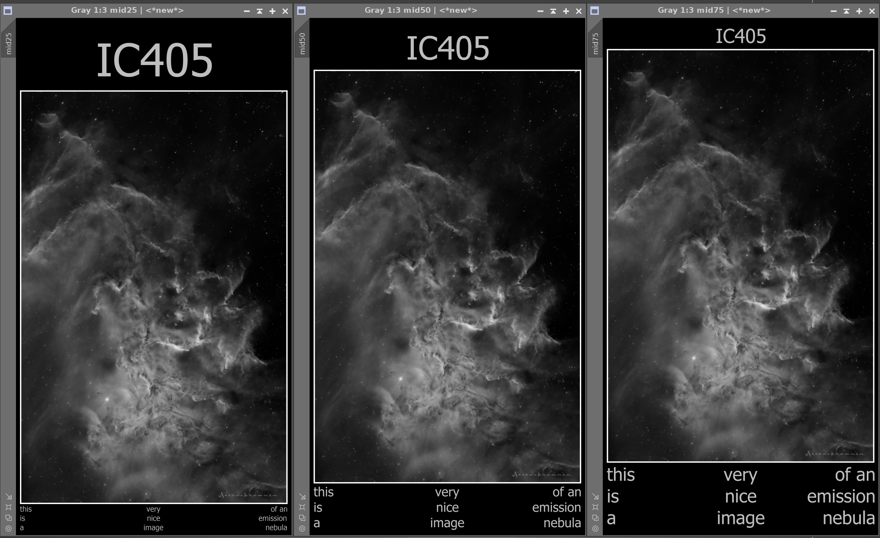

Figure 4 - *Vertical Image Placement* Settings 25%, 50% and 75%

## Frame width (%)

The *frame width* determines how wide the picture frame extends towards the sides.  
Note that this setting has no effect on the scaling of the text, since this is always related to the white inner border.

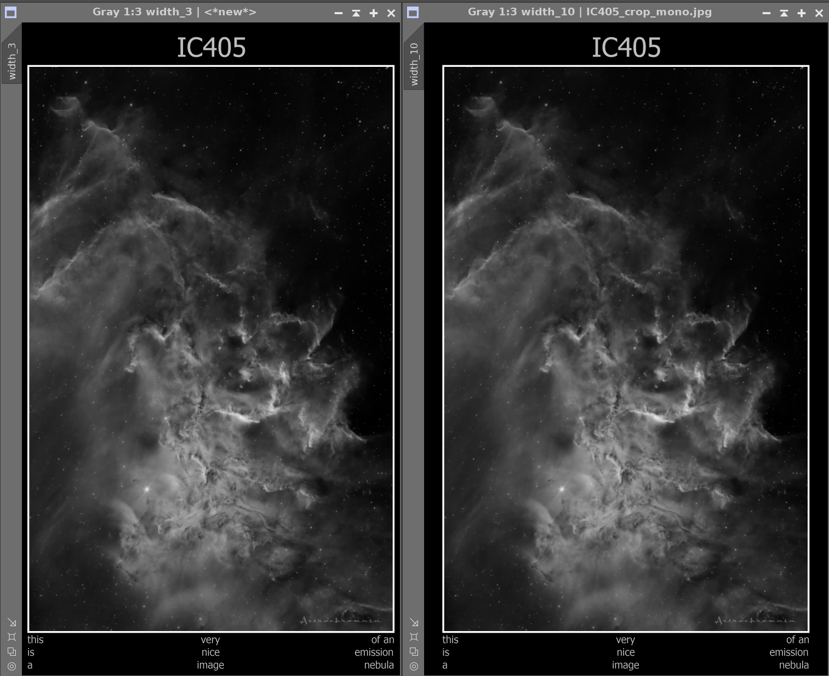

Figure 5 - *Frame Width* Settings 3% and 10%

## Annotation text

Up to three columns of annotation text can be added to the image, consisting of up to three lines each.  
Columns can be enabled individually, space left by disabled column will be made available to the adjacent columns.

The text in the:

* left column will be left aligned,
* center column will be centered,
* right column will be right aligned.

Thus, following esthetically pleasing configurations are possible:

* 3 columns of text
* 2 outer columns of text
* Single centered column of text

# Make adjustments using the stored parameters and history explorer

Since the script stores the settings in the FITS header of the image, you can make use of the PixInSight® *History Explorer* to undo the changes done by the script and adjust settings as needed.

There are several ways to open the *History Viewer* in PixInSight®, for example:

* Right-click the image and select *Load History Explorer*
* Press *Ctrl+Alt+Shift+H*

The *History Explorer* window looks as follows:

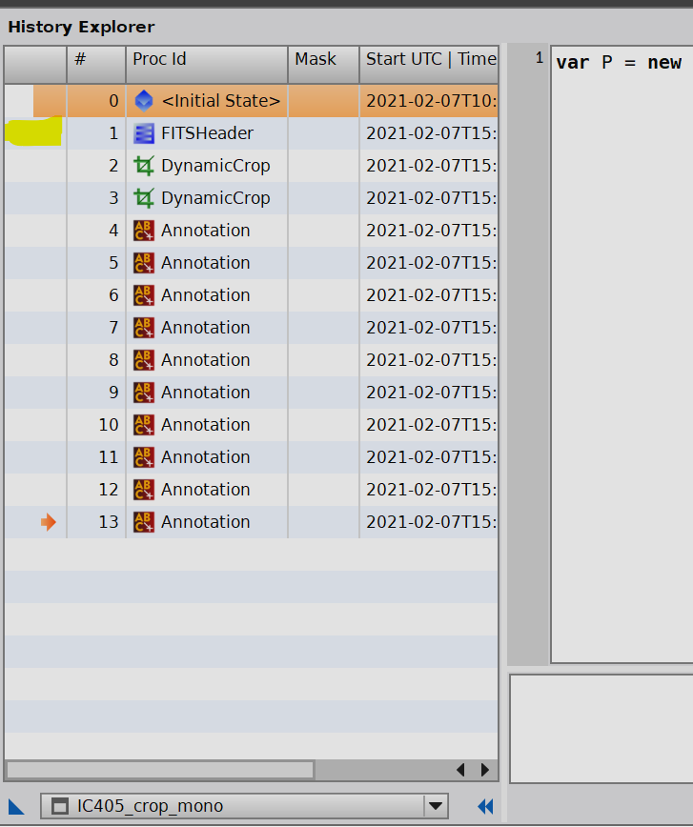

Figure 6 - The *History Explorer* after applying the script

You can see from the history window that the script performed a number of operations in sequence:

* Store the parameters in the FITS header of the image,
* Create the frame using two *DynamicCrop* operations,
* Render the text using multiple *Annotation* operations.

If you are not satisfied with the result of the script, you can adjust the settings after restoring the image version after the FITS Header has been written, but no further operations were done.

To do this, double-click in the first column of the *History Explorer* in the line of the *FITSHeader* operation (marked yellow in image).  
You can then re-open the script, select the image view and your last parameter settings will be restored.

In this way, it is easy to re-iterate until you are satisfied with the result.

1. The maximum font size is 255 pixels due to a PixInSight® limitation.